Unit 5 --Discourse analysis and Lexical resources
Discourse Segmentation:
Discourse segmentation is the process of dividing a text or discourse into meaningful units such as sentences, paragraphs, or subtopics. These segments help in understanding the structure and flow of the discourse. It is crucial in applications like summarization, sentiment analysis, and dialogue systems.
Coherence and Reference Phenomena:
Coherence refers to the logical and semantic connections that make a discourse meaningful and interpretable.
Reference Phenomena involve the use of linguistic elements (like pronouns) that refer to other parts of the discourse for maintaining coherence. These include:
Anaphora: Refers to expressions that depend on preceding text for their meaning (e.g., "John is here. He is happy").
Cataphora: Refers to expressions that rely on succeeding text (e.g., "Before he arrived, John was expected").
Anaphora Resolution: Anaphora resolution is the task of determining the antecedent (the word or phrase to which an anaphor refers).
Two notable algorithms used for this are:
1. Hobbs Algorithm:
A syntactic approach for pronoun resolution.
Traverses a parse tree of the sentence and searches for antecedents in a systematic manner.
Steps involve walking up and down the parse tree to find the most likely antecedent.
2. Centering Algorithm: Uses centers (entities that a discourse is about) to resolve references:
Forward-looking centers: Potential referents in the next utterance.
Backward-looking centers: Referents carried over from the previous utterance.
Attempts to maintain continuity by prefening references to entities that were prominent in the previous utterance. Focuses on local coherence in a discourse.
Coreference Resolution: Coreference resolution is the broader task of identifying when multiple expressions in a text refer to the same entity. It includes:
Resolving anaphors (e.g., "he" in "John said he would come").
Linking nominal references (e.g., "the professor" and "Dr. Smith").
Resources for NLP:
1. Porter Stemmer: A widely used algorithm for stemming (reducing words to their root form).
2. Lemmatizer: Normalizes words to their dictionary form (e.g., "running" → "run").
3. Penn Treebank: A linguistic corpus annotated with part-of-speech tags and syntactic trees.
4. Brill's Tagger: A rule-based part-of-speech tagger.
5. WordNet: A lexical database of English words grouped into synsets with semantic relationships.
6. PropBank: A corpus annotated with predicate-argument structures for semantic role labeling.
7. FrameNet: A database of semantic frames for modeling word meaning and context.
8. Brown Corpus: A standard corpus for linguistic analysis, containing diverse text genres.
9. British National Corpus (BNC): A 100-million-word corpus of British English, covering spoken and written text.
DISCOURSE MEANING:
Discourse refers to communication through spoken or written language. It is a formal term that encompasses the ways in which language is used to convey ideas, engage in dialogue, and construct meaning within a particular context.
DISCOURSE SEGMENTATION
Discourse segmentation is the process of dividing a discourse into smaller units, such as
sentences, clauses, paragraphs, or topics, to understand its structure and meaning more effectively. These units, called discourse segments, help in identifying boundaries and organizing the information for easier interpretation.
Types of Discourse Segmentation:
1. Sentence-Level Segmentation: Splits a discourse into individual sentences.
2. Topic-Based Segmentation: Divides the discourse into sections based on the theme or subject.
3. Dialogue Segmentation: Segments dialogues into conversational tums or speaker utterances.
Example of Discourse Segmentation
InputText:
"John went to the store. He bought some apples. Later, he decided to bake a pie."
Segmented Discourse:
1. Sentence 1: "John went to the store."
2. Sentence 2: "He bought some apples."
3. Sentence 3: "Later, he decided to bake a pie."
Each segment.conveys a meaningful unit of information, contributing to the overall coherence of the discourse.
Coherence:
Coherence refers to the logical flow and connection between segments in a discourse. A coherent discourse enables the reader or listener to understand the relationships between ideas and follow the progression of thought.
Types of Coherence
1. Local Coherence: Connections between adjacent sentences or segments.
2. Global Coherence: Logical consistency across the entire discourse.
Devices for Achieving Coherence
1. Referential Devices
Definition: Use of pronouns or phrases to refer back to earlier elements in a discourse.
Example:
Text: John bought a new car. He is very happy with it.
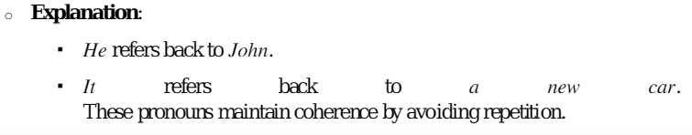
2. Lexical Cohesion
Definition: Repetition of key terms or use of synonyms to link ideas.
Example:
Text: The project was challenging. Despite the difficulties, the team embraced the challenge and completed it successfully.
Explanation:
Challenging and challenge are repetitions of a key term
Difficulties is a near-synonym, reinforcing the theme of overcoming obstacles.
3. Conjunctions and Discourse Markers
Definition: Words or phrases that indicate relationships between sentences or ideas, such as addition, contrast, cause, or sequence.
Example:
Text: The team worked hard. However, the project was delayed due to unforeseen circumstances.
Explanation:
. However signals a contrast between the team's effort and the project's delay, maintaining coherence.
4. Ellipsis
Definition: Omitting repeated words or phrases to avoid redundancy while ensuring meaning remains clear.
Example:
Text: James likes pizza, and Sarah does too.
Explanation:
The phrase likes pizza is omitted after Sarah does, as it is implied.
This omission avoids redundancy while maintaining clarity and coheren
Example of Coherence
Coherent Text:
Anna loves gardening. She spends her weekends planting flowers and vegetables. Her arden is admired by her neighbors."
Coherence Explanation:
The subject (Anna and her gardening activities) is maintained throughout.
Pronoun "she" refers back to "Anna", ensuring cohesion.
The sentences logically follow each other, expanding on Anna's gardening.
Incoherent Text:
"Anna loves gardening. The weather was cold last week. Many people travel during holidays."
Lack of Coherence:
There is no logical connection between the sentences.
The topic shifts abruptly from gardening to weather to holidays.
Example of Topic-Based Segmentation and Coherence
InputText:
"The weather was sunny and warm, perfect for a picnic. Sarah decided to invite her friends for a day at the park. They brought sandwiches, drinks, and games. Later, they enjoyed playing Frisbee and relaxing under the trees."
Segmented and Coherent Text:
1. Segment 1: Setting the Scene
"The weather was sunny and warm, perfect for a picnic."
2. Segment 2: Planning the Activity
"Sarah decided to invite her friends for a day at the park."
3. Segment 3: Enjoying the Picnic
"They brought sandwiches, drinks, and games. Later, they enjoyed playing Frisbee and relaxing under the trees."
Coherence Explanation:
Each segment builds on the previous one, maintaining a logical flow from the weather to Sarah's decision and finally to the picnic activities.
REFERENCE PHENOMENA:
Reference phenomena are linguistic mechanisms used to link words or expressions within - discourse, enabling coherence and meaning. References connect elements in the text referred to as referents) to their mentions (referred to as anaphors or cataphors).
Types of Reference Phenomena
1. Anaphora:
Refers back to an earlier expression in the discourse.
Example: "John arrived late. He apologized.". He refers back to John.
2. Cataphora:
Refers forward to an expression introduced later in the discourse.
Example: "Before he spoke, James took a deep breath."
He refers to James, which appears later in the sentence.
3. Exophora:
Refers to something outside the discourse, often in the surrounding physical context.
Example: "Look at that!"
That refers to something visible in the environment.
4. Endophora:
Refers to elements within the discourse. Includes both anaphora and cataphora.
Example: When she saw him, Mary smiled at John.
"She" is anaphoric, referring back to "Mary."
"Him" is cataphoric, referring forward to "John."
Anaphora Resolution:
Anaphora resolution involves identifying the antecedent (the referent) for a given anaphor.
1. Hobbs' Algorithm:
Hobbs' algorithm is a syntactic approach for resolving pronominal anaphora. It is computationally efficient and widely used in natural language processing (NLP).
Steps of Hobbs' Algorithm:
1. Parse the sentences to generate syntactic trees.
2. Start at the anaphor and traverse the syntactic tree in a breadth-first manner.
3. Check each potential antecedent for compatibility (e.g., gender, number, syntactic role).
4. Select the most suitable antecedent.
Example:
Input Text: "John left early because he was tired."
Anaphor: he.
Antecedent: John.
Hobbs' algorithm identifies John as the referent by traversing the tree and matching syntactic and semantic features.
Centering Algorithm:
The Centering Algorithm is a technique used to ensure coherence in a discourse by analyzing how entities (like people, objects, or ideas) are referenced across sentences. It helps identify the most important subject (called the center) of a sentence and how it connects to the next sentence.
Steps in the Centering Algorithm:
1. Identify Forward-Looking Centers (Cf):
List all entities in the current sentence.
Example: "John went to the park. He played soccer there."
In Sentence 1: Forward-looking centers = {John, park}.
2. Find the Backward-Looking Center (Cb):
Determine the most important entity from the previous sentence that connects to the current sentence.
Example:
In Sentence 2: He refers to John, making John the backward-looking center.
3. Rank the Forward-Looking Centers (Cf):
Rank the entities based on their importance (subjects >objects>others).
Forward-looking centers are ranked based on their importance in the sentence. Typically, subjects (e.g., "John") are ranked higher than objects (e.g., "the park").
4. Check Transitions for Coherence:
Coherence in discourse depends on how the backward-looking center (Cb) changes across sentences. The goal is to minimize unnecessary changes.
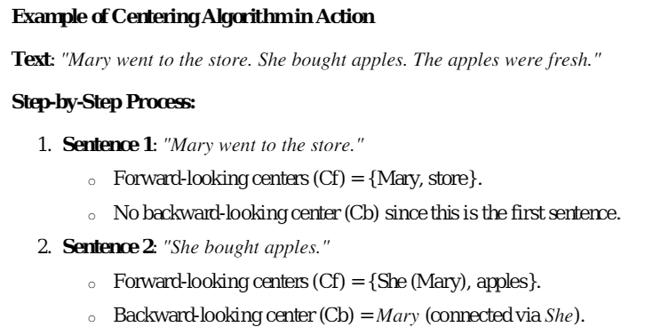
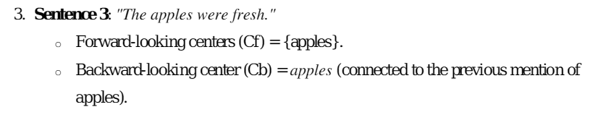
Coherence:
The backward-looking center shifts smoothly from Mary to apples as the discourse progresses, maintaining logical flow and coherence.
COREFERENCE RESOLUTION
Coreference Resolution is the task of identifying when different words or phrases in a text refer to the same entity. It is a key aspect of natural language understanding and is widely used in applications like chatbots, machine translation, and summarization.
Types of Coreference:
1. Anaphora: Refers to an earlier entity in the text.
Example: "John arrived late. He apologized.". He refers to John.
2. Cataphora: Refers to an entity mentioned later in the text.
Example: "When he arrived, John was surprised to see everyone waiting."
He refers to John, mentioned later.
3. Split Antecedent Coreference: Refers to a combination of two or more entities.
Example: "John met Sarah. They had lunch together."
They refers to John and Sarah.
4. Exophora: Refers to something outside the text, often in the physical context.
Example: "Look at that!"
That refers to something observable in the environment.
Steps in Coreference Resolution
1. Identify Mentions:
Locate all noun phrases or pronouns that could refer to an entity.
Example: "John loves his dog."
Mentions: John, his, dog.
2. Extract Features:
Analyze features like gender, number, semantics, and syntactic position.
Example: John (male, singular) matches he (male, singular).
3. Create Candidate Chains:
Group potential references into chains based on matching features.
Example:
Chain: {John, he).
4. Resolve Coreference:
Use algorithms or rules to determine the correct antecedent for each pronoun or noun phrase.
Algorithms for Coreference Resolution:
1. Rule-Based Methods:
Use hand-crafted rules based on linguistic knowledge.
Example:
A pronoun like he typically refers to the nearest preceding male noun phrase.
2. Machine Learning Approaches:
Use supervised leaming to train models on annotated datasets.
Features include syntactic roles, word embedding’s, and distance between mentions.
3. Neural Network Models:
Leverage deep learning to capture complex relationships.
Example: Transformers like BERT can model contextual relationships in coreference tasks.
Use supervised leaming to train models on annotated datasets.
Features include syntactic roles, word embeddings, and distance between mentions.
Example 1: Simple Coreference
Text: "Alice visited the park. She enjoyed the walk."
Coreference: Alice → She.
Example 2: Complex Coreference
Text: "The team worked hard. Their efforts paid off in the end."
Coreference: The team Their.
Example 3: Split Antecedent
Text:
"John greeted Mary. They went to the café."
Coreference: John + Mary They.
Applications of Coreference Resolution
1. Chatbots and Virtual Assistants:
Enable contextual understanding to maintain coherent conversations.
Example: "What is Elon Musk's company? Tell me more about it."
2. Machine translation:
Ensures proper pronoun reference in target languages. Ensures proper pronoun reference in target languages.
3. Text Summarization:
Helps group mentions of the same entity to create concise summaries.
4. Question Answering Systems:
Resolves references in follow-up questions.
Example: "Who won the race? Was he happy?"
RESOURCES: In the context of Natural Language Processing (NLP), resources refer to tools, datasets, and frameworks that help in various tasks like text analysis, machine learning, and language understanding. These resources provide foundational data and methods for processing, analyzing, and understanding language.
1. Porter Stemmer: What It Is:
A stemming algorithm that reduces words to their base or root form by removing common suffixes.
Why It's Used: Helps in text normalization by treating words like "running" and "runner" as the same root word, "run."
Example: Input: "playing, played, playful"
Output: "play"
2. Lemmatizer: What It Is:
A tool that converts words to their dictionary base form (lemma), considering the word's meaning and context.
Why It's Used: Unlike stemming, it ensures that the base form is a real word and more linguistically accurate.
Example: Input: "better". Output: "good"
3. Penn Treebank: What It Is:
A dataset containing annotated syntactic structures and part-of-speech tags for English text.
Why It's Used: Provides a standardized corpus for training and testing NLP models.
Example Annotation:
Sentence: "The dog barked loudly."
POS Tags: [The/DT dog/NN barked/VBD loudly/RB]
4. Brill's Tagger: . What It Is:
A rule-based part-of-speech (POS) tagger developed by Eric Brill.
Why It's Used:
Assigns grammatical tags to words based on contextual rules.
Example:
Sentence: "She runs fast."
POS Tags: She/PRP runs/VBZ fast/RB
5. WordNet: What It Is:
A lexical database for the English language that groups words into synsets (synonym sets) and provides relationships like hypemyms (broader terms) and hyponyms (specific terms).
Why It's Used: Supports tasks like word sense disambiguation and semantic analysis.
Example: Word: "car"
Synsets: {automobile, motorcar}
Hypernym: "vehicle"
6. PropBank
What It Is: A corpus annotated with information about verb arguments and their roles in sentences (semantic role labeling).
Why It's Used: Enables understanding of sentence semantics by identifying "who did what to whom."
Example: Sentence: "John gave Mary a book."
Roles: John (giver). Mary (recipient), book (object)
7. Frame Net: What It Is:
A database that groups words into semantic frames concepts that capture the relationships between words in context.
Why It's Used: Helps in understanding the broader context of sentences.
Example: Frame: Commerce_buy
Sentence: "She bought a car from the dealer."
Roles: Buyer (She), Goods (car), Seller (dealer)
8. Brown Corpus: What It Is:
One of the first large, annotated corpora of English text, covering diverse genres like fiction, news, and academic writing.
Why It's Used: Provides a standard dataset for linguistic analysis and training language models.
Example: Contains over 1 million words categorized into genres like news and editorials.
9. British National Corpus (BNC): What It Is:
A 100-million-word text corpus that represents modem British English from various contexts like books, conversations, and broadcasts.
Why It's Used: Useful for understanding language trends, dialects, and usage pattems in British English.
Example:
Provides frequency counts of word usage, e.g., "colour" is more common than "color."
Install NLTK (Natural Language Toolkit)
NLTK is one of the most popular libraries in Python for NLP. It includes a variety of useful modules for tasks like tokenization, stemming, lemmatization, POS tagging and more. To install NLTK:
Steps:
1. Open a terminal or command prompt.
2. Run the following command to install NLTK via pip:
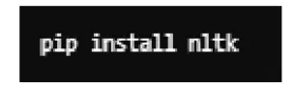
3. After installing NLTK, you can use the following code to download the datasets you need (like WordNet, Brown Corpus, etc.):
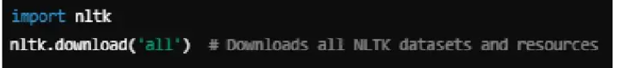
Alternatively, you can download specific datasets
